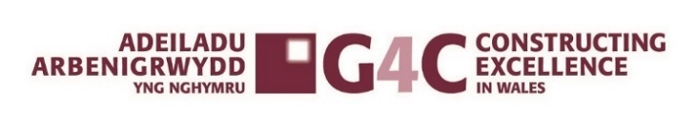
New Professional of the Year 2025
G4C Wales Awards Entry Form

Category Description:

G4C is a driving force for industry change, through the development and connection of future industry leaders. The award is open to a person with less than ten years of experience in the construction and built environment sector (typically less than 35 years of age).

Judges are looking for candidates who have completed professional studies within the construction and the built environment sector within the past 36 months. Applicants should demonstrate how they have excelled in the industry striving to make great contributions to the industry while demonstrating exemplary performance in their field of expertise standing out from their peers. This can be demonstrated through high technical ability, client & customer focus, projects or engaging and responding to the demands faced by clients and the industry. Applicants should demonstrate achievements throughout their career and how they have developed communication, team and leadership skills while aiming to become one of the future leaders of the industry contributing towards delivering a better industry as a whole.
Entry Checklist:

- ☐ Completed entry form
- ☐ Logos – for all key parties that should be recognised for the award sent as a separate file
- ☐ High resolution images (print quality) – up to 5 photos (minimum of 2Mb) sent as a separate file

- Submissions must be received by: midday Friday 11th July 2025
- Completed entry forms and images should be sent to: awards@cewales.org.uk
- Ensure you read and understand the criteria and guidelines before completing this form.
- Information above the specified word limits may not be taken into consideration
- Photo’s and Logo’s in a high resolution format MUST accompany your entry (PDF’s CANNOT be accepted)
- If you do need any assistance, please contact awards@cewales.org.uk or call Sue Selkirk on 07553347099

Good Luck!
G4C Wales & Constructing Excellence in Wales Teams

New Professional of the Year 2025
G4C WALES AWARDS ENTRY FORM SECTION 1 OF 2

Is your entry? | a personal entry ☐ | a nomination ☐

Main contact (this relates to questions/queries about the entry):

Name
Organisation
Email
Telephone
Address
Postcode

Nominee’s contact details:

Name
Position
Current employer
Type of organisation | (i.e. housing association, developer, government department, contractor, consultant etc)
Linkedin Profile

IMPORTANT: Headshot/images – please supply HIGH QUALITY .eps or .jpeg logo files for all organisations mentioned.

New Professional of the Year 2025
G4C WALES AWARDS ENTRY FORM YOUR SUBMISSION │ SECTION 2 OF 2

- Summary

What makes this person a winning individual? Why do you think this individual stands out from the crowd? (max. 400 words)

- Overview

Describe the individual’s role and the context of the submission. (max. 250 words)

- Describe the impact this individual has made within their organization and the industry and the role they have played with key projects? (max. 250 words)

- Sustainability

Evidence the individual’s awareness of sustainability, be it economic, social and/or environmental, and ability to passionately drive positive change and tangible outcomes for their organisation, community and environment. (max. 250 words)

- 3 reasons why you think this individual should win?

Ensure you highlight 3 key achievements.
1

2
3

Deadline for entries: midday Friday 11th July
Send completed entries to awards@cewales.org.uk
If you do need any assistance, please contact Sue Selkirk 07553347099 susan.selkirk@cewales.org.uk

