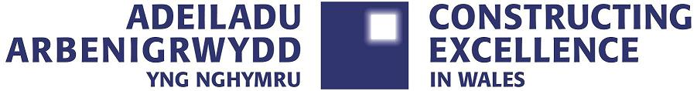

Member Testimonials

2021/2022

***Our sector faces many business challenges including the need to continually innovate, adopt new technologies and deliver greater efficiencies and productivity, CEW enables us to keep up to speed with these changes.***

***CEW is a great place to meet, discuss and celebrate our regional industry on national matters that can influence our project outcomes.***

***CEW’s strategy and portfolio align perfectly with our own business model and aspirations to be part of a smarter and more collaborative construction sector to drive change. CEW’s support for, and engagement with, these aims and objectives enables its members like us to adapt to industry change and deliver better value outcomes.***

***CEW’s inclusive approach to all members of the supply chain regardless of size and turnover provides a forum for acknowledging best and exemplar performance. The suite of CEW events provide an opportunity for discussing current sector initiatives and celebrating its successes.***

***Well worth the membership fee to have involvement and access to a great organisation.***

**CEW is the only organisation that brings together all parties in the construction community in a non-partisan group that works to effect improvements that benefit all involved in or affected by construction. We all have something to contribute to improvement and if you aren't involved then you are missing out on real opportunities to both contribute and derive benefits from membership.**