Supply Chains Made Smarter
How a Digitised Supply Chain can provide Safety Assurance, Provenance, and Accurate Carbon Accounting, together with Positive Economics
Trust in safety-critical products has been seriously undermined by fake data scandals and major disasters such as Grenfell Tower. Finding the truth of a product’s provenance is never more needed than now – and reinforcing steel is one of the most safety-critical elements in any project. Structural engineers also need to understand the environmental impact of their designs and in particular, the carbon footprint of the reinforcing steel.
The CARES Cloud digital solution was developed to address and solve these urgent issues, bringing simplicity to a complex supply chain while restoring trust where it’s missing. By working collaboratively with stakeholders on Europe’s largest infrastructure project, the CARES Cloud tracked each batch of reinforcing steel from its point of origin to the construction site providing compliance and carbon footprint data plus sustainability credentials to achieve credits in BREEAM and/or CEEQUAL/BREEAM Infrastructure.
This Cloud-based solution provides 100% accurate, reliable, easily accessible product information and evidence of assurance and journey through the supply chain, with the ability to update BIM models with data collected from the supply chain and seamless connectivity to other systems via a secure Application Programme Interfaces (API’s).
What is it?
Utilising blockchain technology, the chain of provenance is complete when all reinforcing steel has been delivered to a nominated end user or project premises, and all digital assurance evidence has been confirmed via a dedicated dashboard.
Digital records of key processes that provide further assurance evidence across the supply chain are:
1. All suppliers’ (Manufacturers and Fabricators) CARES certificates of approval for all activities, manufacturing, cutting and bending, welding and preparation of mechanical couplers;
2. All supplier’s (Manufacturers and Fabricators) EPDs, including carbon footprint and quantity, in tonnes, of reinforcement from each manufacturer.
3. Receipt of CARES approved reinforcement from the manufacturer by the fabricator;
4. Allocation of reinforcement to the site by the Fabricator;
5. Delivery acceptance by a named Contractor on site, aligned with accurate information proving product provenance.
How does it look?
Fig1 is an extract is an illustration from the ecosystem of the reinforcing steel journey – From the manufacturer (Steel mill) to the processor, to the construction project site in London.

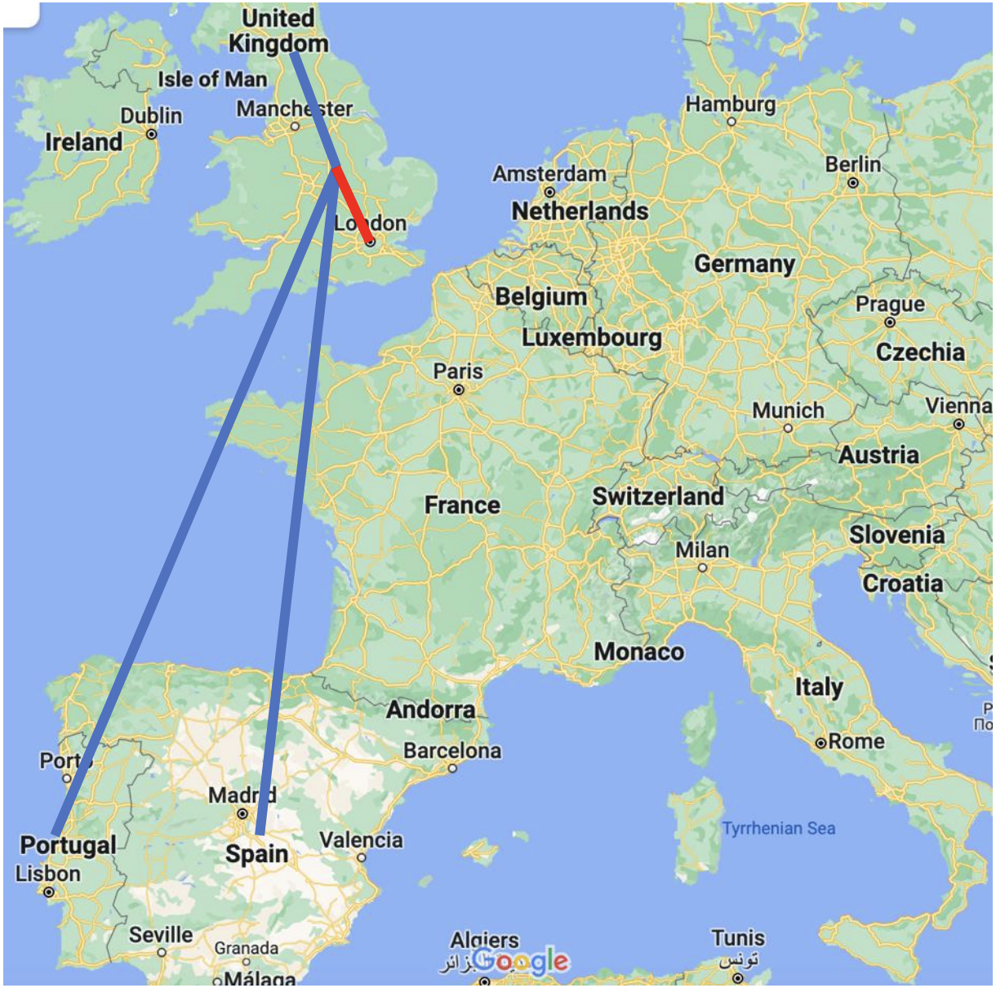
NB this is a high-level geo map, detail for every delivery to the site is contained within the ecosystem
Project Outcomes
This project delivered on all of the objectives set:
1. 100% of steel reinforcement delivered with a complete set of assurance records; all CARES certificates of approval; complete carbon footprint data for all reinforcement manufacturers and fabricators;
2. The data collection process using the CARES Cloud Apps enables dedicated dashboards to record, analyse and summarize the data along the supply chain, in real-time. Summary reports are also provided;
3. Supply chain transparency is delivered via a dedicated project dashboard, providing real-time information, and complying with the Dame Judith Hackett Review of the Grenfell disaster.
4. Carbon savings data can now be quantified, based on the actual manufacturer of the reinforcement and quantities used.
5. Validated the scope of approval of the reinforcement manufacturers and fabricators.
Successful delivery of this project contributes to national strategic and legal objectives, including:
1. Delivery of overarching economic, social and environmental goals.
2. Meeting the challenges of climate change in the built environment and satisfying – The Construction Playbook questions on; How can a digital golden thread integrate design, construction and operation? And; How can strategic collaboration embed improved safety?
3. Supporting the transition of the steel sector to lower environmental impact and resource efficiency, in turn enabling the transition to the circular economy, and
4. Encouraging and facilitating innovation, accelerating maximum benefit from long-term infrastructure investment.
Benefits created (see also Fig2)
The benefits created are as follows:
1. Site productivity uplift - Site productivity was improved by reducing operational time and costs by implementing digital recording of material receipts and demonstrating that paper pro-forma record sheets can be removed. 60,000 tonnes provide a saving of over 900 man-days in processing time. Discounted Cash Flow analysis of this time saving shows a positive Net Present Value against the project implementation.
2. Accurate as-built carbon accounting – enabled the carbon footprint data for all reinforcement manufacturers and the tonnage from each manufacturer, to be reported and analysed via the carbon dashboard. This enabled accurate collection and reporting of reinforcement manufactured in the UK and elsewhere.
3. Carbon footprint saving – enabled procurement to make design procurement strategies that gave preference to lower emission steel sources. The CARES Cloud unlocked the ability to do this based on the carbon price used at the time of £50 per tonne. This creates a (non-cash) saving of over £3,600,000 in CO2e for 60,000 tonnes of rebar based on a carbon price of £50 per tonne of CO2eq and a GWP of 0.760 tCO2eq per tonne of rebar.
4. Decarbonisation contribution - The carbon savings and digital data exchange can contribute towards corporate commitments to reduce carbon emissions in line with defined pathways, such as procuring 50% low-emission steels by 2030.
5. Data sharing and integration - Data contained within the CARES Cloud, including accurate carbon data, can be automatically integrated into software like Optimise and others via a secure API.
6. Reduced rebar wastage – digital delivery confirmation of tonnage received at the site, including capturing GPS co-ordinates, will reduce the quantity of rebar lost on-site, duplicate ordered and misused.
7. Improved assurance processes – This solution provides more detailed assurance evidence as well as reliable, accurate, easily accessible product information and evidence of assurance for inclusion in project BIM models, enabling seamless connectivity to other systems. All reinforcement manufacturers, fabricators (processors) and all CARES certificates of approval, including revisions as scopes of approval, which may change over the duration of the project, are recorded, accessible and summarised on a dedicated dashboard.
8. Design (future benefit) - At the design stage, structural engineers will be able to understand the environmental impact of their designs based on as-built data and make better-informed design decisions and give preference to lower emission steel sources.
9. Future proofing (future benefit) – alignment with and meeting the current and future regulatory requirements for a safety critical product such as reinforcing steel as defined in the Building Safety Act 2022 and the forthcoming secondary regulations, including the 'Golden Thread' of information, refer to Annex 4 for further information.
Fig2
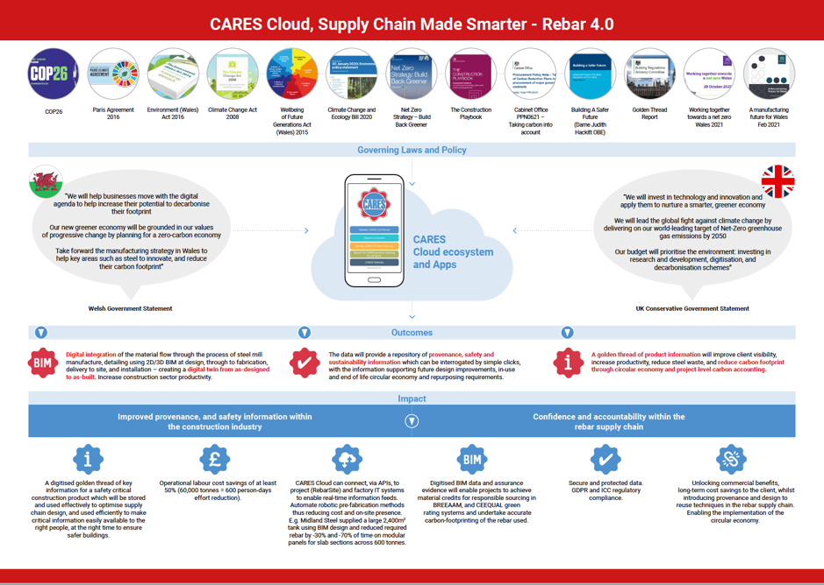
Ahead of the future requirements

All in all – The Cares Ecosystem is ahead of the game and already allays some of the fears and requirements in the construction industry, including the most recent high-level construction-related reports;
Building a Safer Future – Dame Judith Hackitt stated that; The system that covers product testing, labelling and marketing is at least as complicated as the entire regulatory system which was mapped in the interim report. It is apparent that the current system makes it difficult to know whether the right products are being used!
Testing for a Safer Future – Paul Morrell OBE has defined; How should the UK system for testing the safety of construction products and the use of data from the system be strengthened, to inspire confidence that those products are safe and perform as labelled and marketed when incorporated into construction work?

