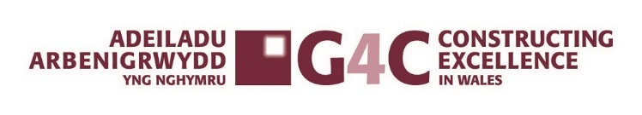
Apprentice of the Year 2024
G4C Wales Awards Entry Form
Category Description:

G4C is a driving force for industry change, through the development and connection of future industry leaders. The award is open to a person with less than ten years of experience in the construction and built environment sector (typically less than 35 years of age).

Judges are looking to award apprentices (Technical or Trade) who are working towards or who have completed an apprenticeship within the last 12 months. Judges are looking for exemplars who showcase the difference they have made in the industry and the organisations that they work in. Entries should demonstrate how the person has created a positive impact on the industry, organisations or college through a commitment of personal development.
Entry Checklist:
To be included in your submission:

- ☐ Completed entry form – low resolution images can be embedded to support your entry.
- ☐ Logos – for all key parties that should be recognised for the award sent as a separate file.
- ☐ High resolution images (print quality) – up to 5 photos (minimum of 2Mb) sent as a separate file.

- Submissions must be received by: Friday 20th September 2024
- Completed entry forms and images should be sent to: awards@cewales.org.uk
- Ensure you read and understand the criteria and guidelines before completing this form.
- Information above the specified word limits may not be taken into consideration
- Photo’s and Logo’s in a high resolution format MUST accompany your entry (PDF’s CANNOT be accepted)
- If you do need any assistance, please contact awards@cewales.org.uk or call Sue Selkirk on 07553347099

Good Luck!
G4C Wales & Constructing Excellence in Wales Teams
Apprentice of the Year 2024
G4C WALES AWARDS ENTRY FORM SECTION 1 OF 2

 | Technical Apprentice ☐ | Trade Apprentice ☐
Is your entry? | a personal entry ☐ | a nomination ☐

Main contact (this relates to questions/queries about the entry):

Name
Organisation
Email
Telephone
Address
Postcode

Nominee’s contact details:

Name
Position
Current employer
Type of organisation | (i.e. housing association, developer, government department, contractor, consultant etc)
Linkedin Profile (if applicable)

IMPORTANT: Headshot/images – please supply HIGH QUALITY .eps or .jpeg logo files for all organisations mentioned.

Apprentice of the Year 2024
G4C WALES AWARDS ENTRY FORM YOUR SUBMISSION │ SECTION 2 OF 2

- Summary (max. 400 words)

What makes this person a winning individual? Why do you think this individual stands out from the crowd?

- Overview: Describe the individual’s role and the context of the submission. (max. 250 words)

- 3 reasons why you think you should win?

Ensure you highlight 3 key achievements.
1

2
3

17th
Deadline for entries: Friday 20th September
Send completed entries to awards@cewales.org.uk
If you do need any assistance, please contact Sue Selkirk 07553347099 susan.selkirk@cewales.org.uk

June 2019 – via email to susan.selkirk@cewales.org.uk

