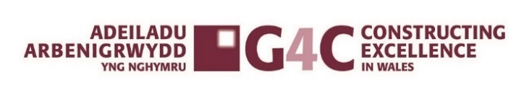
Mentor of the Year 2024
G4C Wales Awards Entry Form
___________________________________________________
Category Description:

G4C is a driving force for industry change, through the development and connection of future industry leaders.

Judges are looking for individuals who have shown a commitment to developing the future leaders of the industry, investing time and nurturing while offering support and guidance. Applicants should show commitment to developing, nurturing and encouraging new entrants into the industry offering unbiased guidance. Judges are looking for an individual who has a good knowledge of current topics in the industry and who is developing with the changing industry. Applicants should have a keen interest in mentoring, aiming to influence mentees to become one of the future leaders of the industry, contributing towards delivering a better industry.
Entry Checklist:

- ☐ Completed entry form – low resolution images can be embedded to support your entry.
- ☐ Logos – for all key parties that should be recognised for the award sent as a separate file.
- ☐ High resolution images (print quality) – up to 5 photos (minimum of 2Mb) sent as a separate file.

- Submissions must be received by: Friday 20th September 2024
- Completed entry forms and images should be sent to: awards@cewales.org.uk
- Ensure you read and understand the criteria and guidelines before completing this form.
- Information above the specified word limits may not be taken into consideration
- Photo’s and Logo’s in a high resolution format MUST accompany your entry (PDF’s CANNOT be accepted)
- If you do need any assistance, please contact awards@cewales.org.uk or call Sue Selkirk on 07553347099

Good Luck!
G4C Wales & Constructing Excellence in Wales Teams
Mentor of the Year 2024
G4C WALES AWARDS ENTRY FORM SECTION 1 OF 2

Is your entry? | a personal entry ☐ | a nomination ☐

Main contact (this relates to questions/queries about the entry):

Name
Organisation
Email
Telephone
Address
Postcode

Nominee’s contact details:

Name
Position
Current employer
Type of organisation | (i.e. housing association, developer, government department, contractor, consultant etc)
Linkedin Profile (if applicable)

IMPORTANT: Headshot/images – please supply HIGH QUALITY .eps or .jpeg logo files for all organisations mentioned.

Mentor of the Year 2024
G4C WALES AWARDS ENTRY FORM YOUR SUBMISSION │ SECTION 2 OF 2

- Summary

What makes this person a winning individual? Why do you think this individual stands out from the crowd? (max. 400 words)

- Overview

Describe your role and how have you progressed within the built environment sector demonstrating your commitment to people development. (max. 250 words)

- Describe the impact you have made within your organisation and the industry role you have played? (max. 250 words)

- Demonstrate how you are guiding and influencing the industry’s next generation? (max. 250 words)

- 3 reasons why you think you should win?

Ensure you highlight 3 key achievements.
1

2
3

Deadline for entries: Friday 20th September
Send completed entries to awards@cewales.org.uk
If you do need any assistance, please contact Sue Selkirk 07553347099 susan.selkirk@cewales.org.uk

