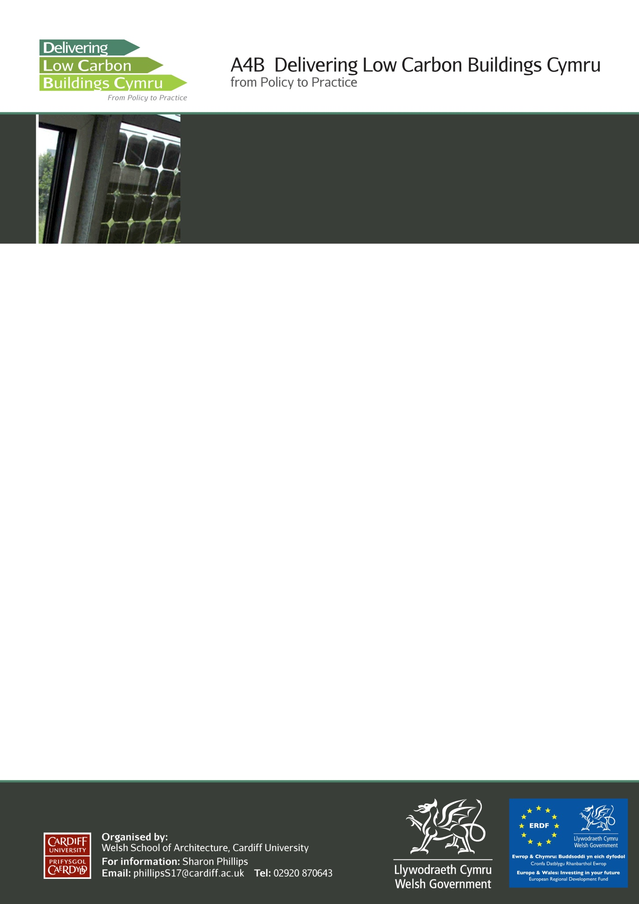

Welsh School of Architecture A4B Final Conference

9.30 – 4.30 pm Thursday 28th June 2012

Aberdare Hall, Cardiff University

**AGENDA**

09.15 Registration & Coffee

Welcome – Prof Phil Jones (WSA)

Guest Speaker – Welsh Building Regulations Update

Coffee

Breakout Sessions

Lunch

Breakout Sessions

Where do we go from here? - Prof Phil Jones (WSA)

**Breakout Sessions to include :** Learning from low carbon

Compliance and regulation

Modelling and prediction

Cost

Low carbon case studies